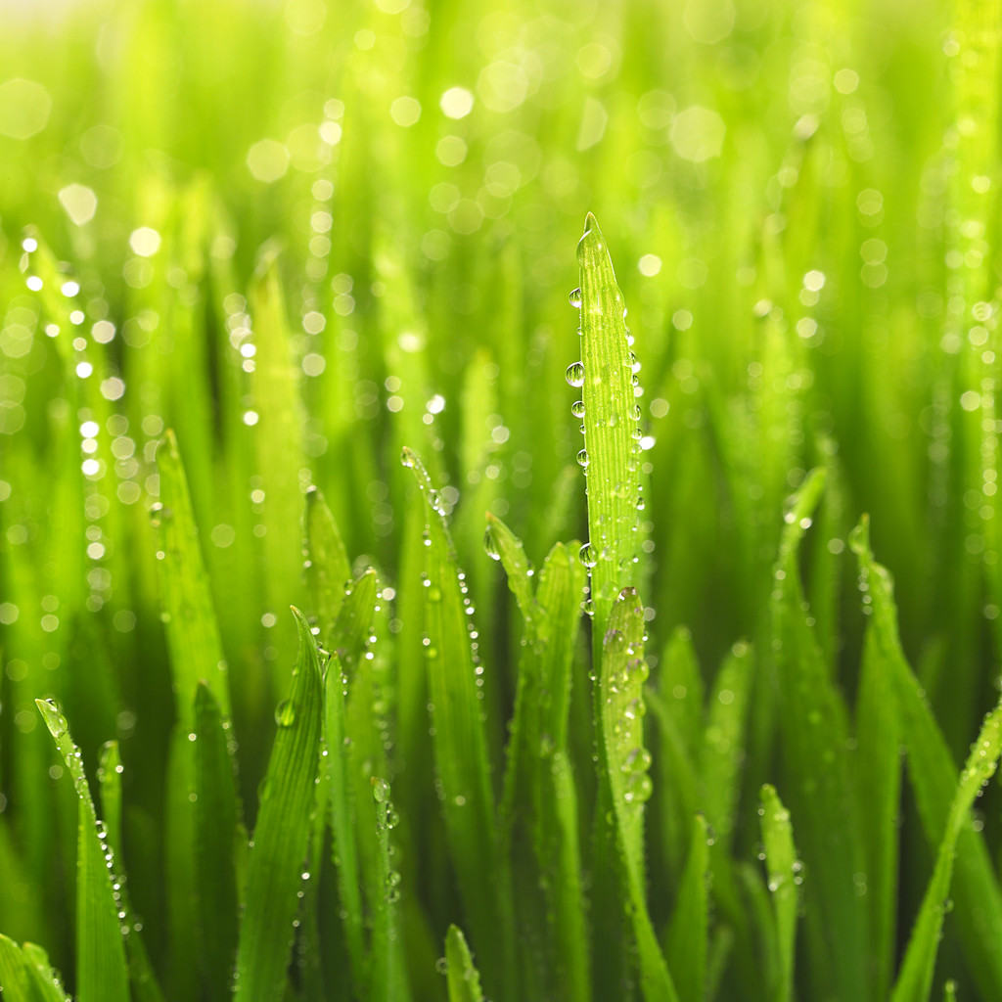
Clear Things Up

The word ecosystem refers to all the living organisms in a particular location as well as all the nonliving parts of their physical environment. Coastal ecosystems are places where land and seawater come together. If you have ever been to a beach on the ocean or large bay of water, then you have seen a coastal ecosystem. These places are home to many various plants and animals but they are also very fragile and can be affected by even very small changes in the environment.
Seagrasses are underwater plants that help keep coastal environments stable. In this activity, you will learn about the importance of seagrasses.

Removing Extra Nutrients
If a coastal ecosystem is healthy, the water will be clear and there will only be small amounts of algae growing. There will be the right amount of nutrients for plants and animals. However, if too many nutrients enter the ecosystem, algae can begin to grow in excess, causing an algal bloom. When all these algae die and start to get decomposed by bacteria, the bacteria remove oxygen from the water and this can cause many other organisms to die.

Preview Questions
1. Excess nutrients can come from many natural sources including the atmosphere and soil erosion as well as unnatural sources like fertilizers and sewage. What are 2 specific examples of unnatural sources that might add extra nutrients to the water here in our community?

Recently in our county, it has been found that an excess of nutrients have been building up in the local streams, ponds, and reservoirs. Some local experts have proposed enormously expensive filtering methods to remove these extra nutrients, but the proposal was denied. Since the students at our school are known for being very smart and inventive it is now up to our class to design a new “natural” way to remove excess nutrients from the water supply using underwater grasses. Your job will be to provide evidence supporting the idea that underwater grasses can remove excess nutrients from the water.

In your group, design an experiment to test the idea that underwater grasses remove excess nutrients from the water. Be sure to include all steps for setting up a controlled experiment.
Supplies available:
Glass jars, pond water with algae, fertilizer with phosphorous, underwater grass

After you have discussed your plan with the rest of the class, include the experimental set-up on your own paper. You will be making observations in the near future.
Procedure
In this activity, you will observe what happens to the water in the various environments that you decided on in the introduction activity. On your own paper, create a data table. Include a column for the date and a column for each of the experimental conditions that you have chosen.

Observe the jars at least 3 times over the next 7 days. Record your data in your data table.

Draw what each of the jars looked like on the final observation day. Write a brief description of each jar below your drawing, including as much detail as possible.

Explain:
- Which jar contained water that looked most similar to the water from the first day? Does this jar represent an environment with more or less nutrients? Explain WHY certain jars would be more likely to contain water that looked the same on the last day as they did on the first day.
- Which jar had water that looked like it contained the smallest amount of fertilizer on the last day? Does this jar represent an environment with more or less nutrients? What do you think happened in this jar?
- Summarize what you learned about underwater grasses from this activity.

